Experiment No 4

Aim: Write a program to implement Lexical analyzer

Learning Objective: Converting a sequence of characters into a sequence of tokens .
Theory:
THE ROLE OF LEXICAL ANALYZER

The lexical analyzer is the first phase of a compiler. Its main task is to read the input
characters and produce as output a sequence of tokens that the parser uses for syntax analysis. Upon receiving a “get next token” command from the parser, the lexical analyzer reads input characters until it can identify the next token.

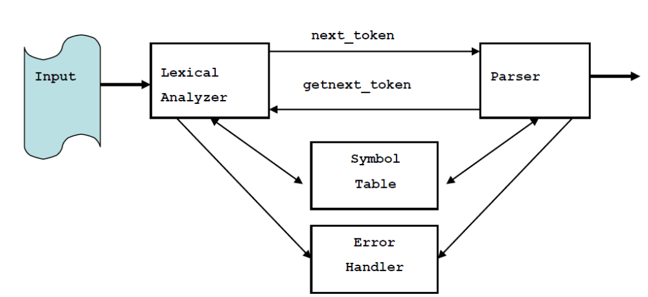
Figure 4.1 Interaction of Lexical Analyzer with Parser

Since the lexical analyzer is the part of the compiler that reads the source text, it may also perform certain secondary tasks at the user interface. One such task is stripping out from the source program comments and white spaces in the form of blank, tab, and new line characters. Another is correlating error messages from the compiler with the source program. Sometimes lexical analyzers are divided into a cascade of two phases first called “scanning” and the second “lexical analysis”. The scanner is responsible for doing simple tasks, while the lexical analyzer proper does the more complex operations.

Implementation Details
- Read the high level language as source program
- Convert source program in to categories of tokens such as Identifiers, Keywords, Constants, Literals and Operators.
Test cases:
- Input undefined token

Conclusion:

Post Lab Questions:
- Take any one statement of programming language and parse into different phases of compiler.
- What is symbol table?

